Day 2: The Summer Job

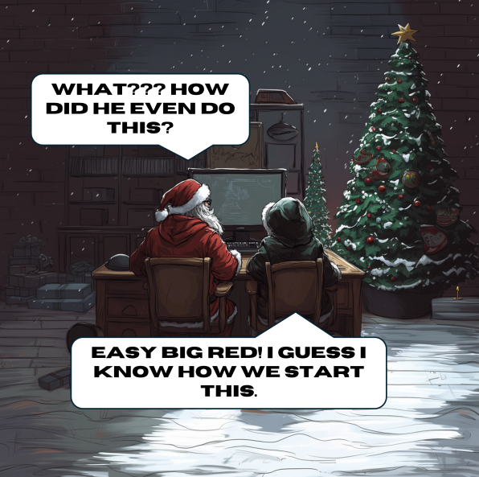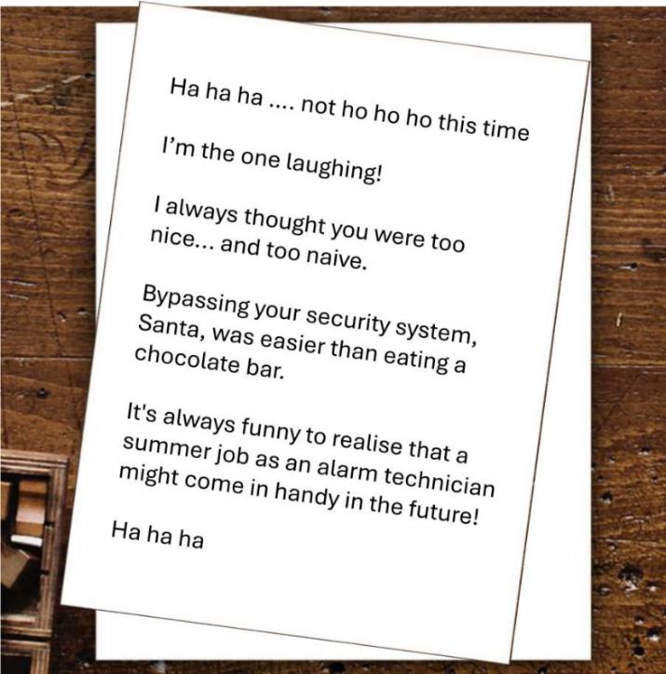

*Q: What is the name of the company the thief worked for?*

The above image of a letter is attached to this question. It supposably is the letter we saw on the picture from day 1 as well, although we could not read it at that time. The letter states that the thief had a summer job as an alarm technician. The statement about the chocolate bar might also be a clue. For now, let’s look if there’s any metadata again. Unfortunately, no metadata is found by looking at the properties, nor using the Forensically and Exiftool tools. It looks like I only have the text to go on. There seem to be no businesses that deal with alarm systems in this area of Lapland. The wayback machine also shows no vacancies for alarm technicians in the Santa Claus Holiday Village for the summer of 2024. Looking back at the text, maybe the “ha ha ha” is a hint. So, I Googled for: alarm technician ha ha ha. The results show a business called Home Assistant that deals with alarm systems. This might be what I’m looking for, since the abbreviation of Home Assistant is ha! However, this answer does not seem to be correct. Maybe I have to look for fictional characters in comedy movies, since the text makes multiple references to comedy (e.g., “laughing”, “funny”). My first thought went to the Home Alone movies, which coincidentally also abbreviate to ha. So, I Googled for: "home alone" burglars company. The fourth result, a Home Alone wiki on Fandom, mentions that the burglars in the Home Alone movie drove a van that read “Oh-Kay Plumbing and Heating”. It seems a stretch, but worth a try. This answer is not correct however. I broadened my search now, but additionally specifying that I’m looking for a villain character, which seems plausible by the tone of the letter. My next search query is the following: “alarm technician” funny villain movie. A movie pops up called Paris-Manhattan. Reading through the plot, it doesn’t seem fitting as the movie is not well-known and the alarm technician occupation is not very central in the plot. Scrolling further through the results, I come across an interview with Marc Hershon that mentions he played an alarm technician in a movie called Santa Jr. This seems exactly what I’m looking for! Looking closer at the Santa Jr. movie, I am unable to find the business that the Marc Hershon character was working for. Still, I think it is a good lead. Reading the interview with Marc Hershon more closely, it explains that he is mainly a screenwriter. So, the summer job reference in the letter might refer to Marc Hershon rather than his Santa Jr. character. Googling Marc Hershon, I find his LinkedIn page. Among other things, his bio reads that he has made several movies for the Hallmark Channel. This seems to be what I’m looking for! Hallmark is Christmas-themed and also starts with ha! Strangely, this answer (in a number of different varieties) is incorrect. I am baffled at this point and will skip this challenge.

Update 25 December 2024: I watched the walkthrough provided by OSINT Switzerland to find out the correct way to approach this challenge. This has given me some more inspiration for the next challenges.